Mohammed Mustafa Ali Almajed

|  |
| --- |
|  |
|  |
|  |

*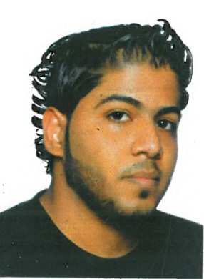****Personal Information:***

*Name: Mohammed Mustafa Ali AlMajed*

|  |
| --- |
|  |
|  |
|  |

|  |
| --- |
|  |
|  |
|  |

*Nationality: Bahraini*

*Religion: Muslim*

*Sex: Male*

***Contact Information***

*Build No - 2813 , No Street- 1144 ,Block - 1211 Hamad Town*

***Mobile Phone: +97333393721***

***Email : Zom.17@hotmail.com***

*CPR No : 920500447*

*Date of Birth : 15/05/1992*

*Marital Status : Married*

***Objective:***

*Looking forward to associate myself with an organization of quality environment where knowledge can be shared and dedicate my skills and talents for development of self and the organization served.*

***Education Qualification:***

*Secondary School Certificate (Second Year )*

***Skills :***

* *Interpersonal Skills : good communication skills ,work will in both team environment and individual assignments*
* *Ability to work under pressure and as a part of team ,*
* *Languages :*
* *Arabic (Mother Tongue)*

*Hindi (Very good)*

*, English (good)*

* *Driving License*

***Work Experiences:***

* *Worked as a Operator in Medal Company ( 5 Years )*
* *Worked as a Sales Man in RADTAG (Three Months )*